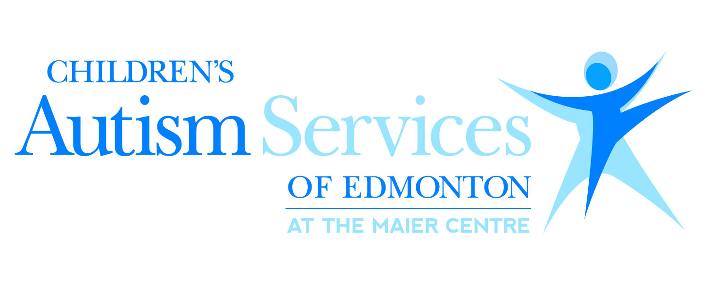

**Cooking with Friends**: This group is ideal for children aged 5 to 14 years old. The child will learn simple kitchen skills, and have exposure to foods in fun and interesting ways. The child should be comfortable staying around the food when different types of food are presented. There is a materials fee per child of $30.

**Session 1:** Maier Centre South

**Time:** 4:30 pm – 5:15 pm

**Session 2:** Maier Centre South

**Time**: 5:15 pm – 6:00 pm

The sessions take place every Wednesday from October 10th to November 21st. Please note that there is no class on October 31st.

***Empowering families with autism – for life***

