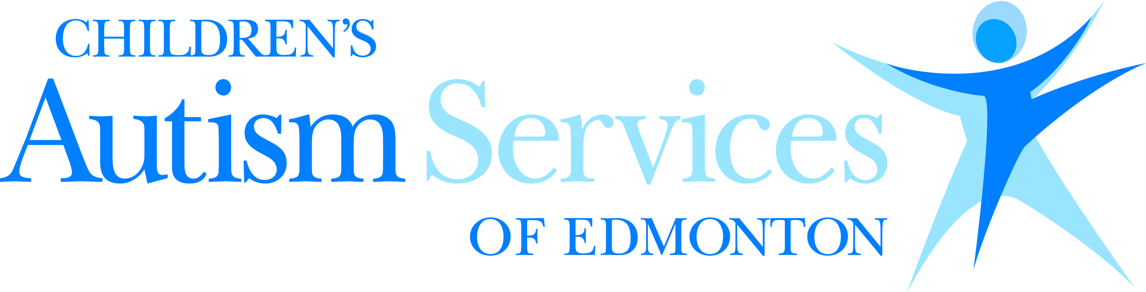
EPIC – Dynamyx Gymnastics (6-10 years)
– Active Discovery

Recent literature on programs emphasizing gymnastics for children diagnosed with autism indicates positive results from increased gross motor function to improved fine motor control, better posture, and increased independence in following instruction. In partnership with Dynamyx Gymnastics Club, children will work on gross motor play, as well as focus on turn-taking and following group instructions in a safe and supportive environment. Children will also have the chance explore the many different sensory opportunities that the gymnastics environment has, such as crawling through the foam pit and walking on various surfaces and apparatuses of varying heights. Following the Children’s Autism Services of Edmonton philosophy, participants will be supported through the SCERTS (Social Communication, Emotional Regulation, and Transactional Supports) model.
Who: Children ages 6-10 yrs

When: Beginning October 10, 2018 (8 weeks)

Time: 4:00-5:00pm

Where: Bay 104, 25 Chisholm Avenue,
St. Albert, AB

Cost: $325.00/session
(Please note that this does not include the one-time $40.00 membership fee. This fee is not applicable to those who have previously participated at Dynamyx over the course of this year.)

For More Information and to register send an email to:
epic@childrensautism.ca

