**image001.jpg**

**11TH ANNUAL Autism CONFERENCE**

**JANUARY 24th & JANUARY 25th, 2019**

***Thursday Keynote #1: Steve Silberman – Neurotribes***

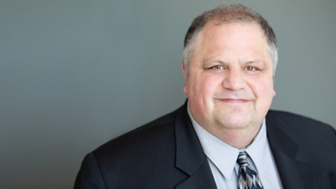Steve Silberman is the author of ***NeuroTribes: The Legacy of Autism and the Future of Neurodiversity*.** He’s also an award-winning science writer, and his TED talk, “The Forgotten History of Autism,” has been viewed more than a million times and translated into 25 languages.

In his book and his keynote presentations, Silberman shares little-known stories of the researchers and psychiatrists who pioneered the first autism diagnoses while also providing long-sought solutions to the autism puzzle. In an effort to shed light on the growing movement of “neurodiversity,” Silberman discusses the evolution of autism and explores the need for a more humane world in which people with learning differences and those who love them have access to the resources they need to live happier, healthier, more secure, and more meaningful lives.

***Thursday Keynote #2: Kerry Magro - Personal Experience of Autism Intervention***

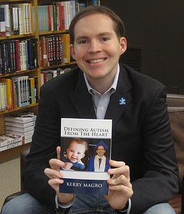

Award Winning and Breakthrough Advocate Kerry Magro knew early on that he wanted to make a difference in the lives of others. Kerry was diagnosed with Pervasive Developmental Disorder-Not Otherwise Specified (PDD-NOS) a form of autism, at age 4. Growing up Kerry’s future was very uncertain.

Today however, after countless hours of therapy and the support of a loving family, Kerry has conquered many of his challenges. Now as an adult Kerry is a professional speaker, best-selling author, movie consultant and non-profit founder. In 2013, Kerry released his first book Defining Autism From The Heart which became an Amazon Best-Seller.

**Thursday Speaker: Dr. Stelios Georgiades – Research Trends in Autism**

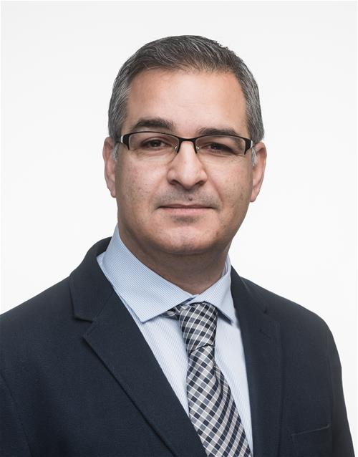Dr. Stelios Georgiades is an Assistant Professor in the Department of Psychiatry and Behavioural Neurosciences and a Scientist at the Offord Centre for Child Studies at McMaster University. His program of research investigates clinical heterogeneity in autism with an emphasis on understanding the factors and mechanisms influencing the developmental trajectories of children and youth on the spectrum. The overarching objective of this research is to generate new knowledge that will lead to more precise, evidence-based diagnostics and interventions for Autism Spectrum Disorder (ASD).

Dr. Georgiades is the Founder and Co-Director of the McMaster Autism Research Team (MacART), an interdisciplinary collaborative aiming to advance autism care through meaningful research. This includes the Pediatric Autism Research Collaborative (PARC) Project which is bridging the research-to-practice gap by embedding a research protocol within the ASD services clinic at McMaster Children’s Hospital.  Dr. Georgiades is Co-lead for the McMaster site for the Pathways in ASD study, a Canada-wide longitudinal study of children and youth with ASD – the largest of its kind and the largest longitudinal ASD study to date.

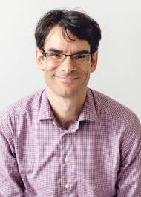**Thursday Speaker: Dr. Lonnie Zwiagenbaum – Research Trends in Autism**

Dr. Zwaigenbaum is a developmental pediatrician and site lead for Child Health at the Glenrose Rehabilitation Hospital, where he directs the Autism Research Centre. After completing his clinical fellowship training in 1996 at SickKids, Dr. Zwaigenbaum completed a research fellowship and MSc in Health Research Methodology at McMaster University, where he held his first faculty position. He became the Stollery Children’s Hospital Foundation Chair in Autism Research in 2006 and is currently Professor in the Department of Pediatrics at the University of Alberta.

His research focuses on early behavioral and biological markers, and developmental trajectories of autism spectrum disorders (ASD) as well as lived experience in youth with ASD and their families. He holds funding as PI from CIHR, Brain Canada-Azrieli Foundation, Kids Brain Health Network and Autism Speaks. Dr. Zwaigenbaum has also been the program director for the national Autism Research Training Program since 2011.

**Thursday Speaker: Ken Robertson – Supporting Children with Autism in the Indigenous Community**

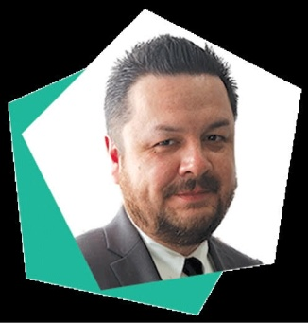Ken Robertson is Secwepemc from Neskonlith Indian Band located in the south-central part of British Columbia. Raised in East Vancouver known as ‘Canada’s poorest postal code’ similar to many First Nations peoples, he had challenges accessing services on reserve. Ken moved to Toronto in his youth and held positions at Tumivut Youth Shelter, and later the Native Canadian Centre of Toronto.

Shortly after the diagnosis of Autism of two of his children Ken began advocating for Autism parents when he ran in the 2014 municipal election for Toronto District School Board Trustee placing second. Current Board Member of Autism Ontario and successfully launched a House of Commons E-petition advocating for services for First Nations families off-reserve. His continued goal is advocating for all Autism parents, and addressing the challenge each family faces.

**Friday Keynote Speaker: Dr. Pamela Wolfberg – Peer Play and ASD & Integrated Play Groups**

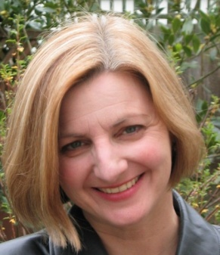

Pamela Wolfberg, Ph.D. is a professor in the Department of Special Education at San Francisco State University where she coordinates Autism Spectrum Studies and serves on faculty for the Joint Doctoral program with the University of California, Berkeley. Her interests center on the unique experiences of people on the autism spectrum in the areas of socialization, play and imagination, and inclusion in peer culture. As originator of the Integrated Play Groups (IPG) model and a human rights advocate, she leads research, training and global outreach to advance social inclusion in play and cultural experiences that allow for meaningful interaction and creative expression. She has extensively published in peer-reviewed journals and is the author of many books and chapters. She has an active agenda as an invited international speaker and is the recipient of several eminent awards for her scholarship and service to the community.

**Friday Speaker: Stephanie Mitelman – Youth and Adult Autism Sexuality**

[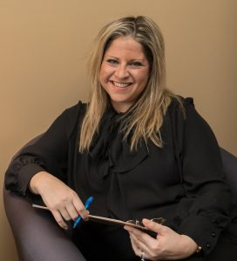](http://sexpressions.ca/images/stephanie-mitelman.jpg)Stephanie Mitelman is Part Time Faculty at Concordia University and an AASECT Certified Sexuality Educator. She is a National trainer for schools, school boards and organizations with her Understanding Adolescent Sexuality & Teaching Sex Ed, and ABC’s of Sexuality and Autism Spectrum Disorders trainings. Her work focuses primarily on prevention issues and healthy relationships.  
  
Stephanie is also founding member of the Sexual Health Network of Quebec (re-launched from the Planned Parenthood Chapter of Montreal in 2005).

She has created programs, curriculums and teaching tools for many schools, including several Aboriginal communities. As a sexuality education specialist, she also works with individuals and couples with special needs, with a focus on Autism Spectrum Disorders. She also has a private practice, and see individuals privately. In 2013, Stephanie was awarded the First Tracks Award for Innovation in Sexology for her work in making sex education more accessible for people on the autism spectrum.

|  |  |
| --- | --- |
| River Cree Resort: Thursday, January 24th | |
| **8:00am - 9:00 am** | **Registration & Breakfast at River Cree Resort** |
| **9:00 am – 10:30 am** | **Keynote Speaker #1: Steve Silberman - Author of Neurotribes** |
| **10:30am – 11:00 am** | **Morning Break** |
| **11:00am - 12:30 pm** | **Keynote Speaker #2: Kerry Magro - Personal Experience with Autism Intervention** |
| **12:30 – 1:30 pm** | **Lunch** |
| **1:30 – 3:00pm** | **Concurrent Sessions:**  **A: Ken Robertson – Supporting Children with Autism in the Indigenous Community**  **B: Autism in the Classroom** |
| **3:00 – 3:15pm** | **Break & Snacks** |
| **3:30 - 4:30 pm** | **Concurrent Sessions:**  **A: Ken Robertson – Supporting Children with Autism in the Indigenous Community**  **B: Autism in the Classroom** |

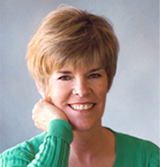 *schedule - subject to change

|  |  |
| --- | --- |
| River Cree Resort: Friday, January 25th | |
| **8:00 – 9:00am** | **Registration & Breakfast at River Cree Resort** |
| **9:00 – 10:30am** | **Keynote Speaker:**  **Dr. Pamela Wolfberg: Peer Play and ASD** |
| **10:30 – 10:45am** | **Morning Break** |
| **10:45 – 12:00pm** | **Keynote Speaker:**  **Dr. Pamela Wolfberg: Peer Play and ASD** |
| **12:00 – 1:00pm** | **Lunch** |
| **1:00 – 2:30pm**  **Concurrent sessions** | **A:** **Pamela Wolfberg - Integrated Play Groups**  **B: Stephanie Mitelman - Youth & Adult AutismSexuality**  **C: Lonnie Zwaigenbaum and Stelios Georgiades – Research Trends in Autism** |
| **2:30 – 3:00pm** | **Break & Snacks** |
| **3:00 – 4:30pm**  **Concurrent sessions** | **Concurrent Sessions:**  **A:** **Pamela Wolfberg - Integrated Play Groups**  **B: Stephanie Mitelman - Youth & Adult AutismSexuality**  **C: Lonnie Zwaigenbaum and Stelios Georgiades – Research Trends in Autism** |

 *schedule - subject to change

**VISIT** [**CHILDRENSAUTISM.CA**](http://www.childrensautism.ca/) **OR** **CALL (780) 495-9235 FOR MORE INF0**